CHEMICAL ENGINEERING TRANSACTIONS  VOL., 2023 | A publication of
The Italian Association
of Chemical Engineering
Online at www.cetjournal.it

Guest Editors: Sauro Pierucci, Jiří Jaromír Klemeš
Copyright © 2023, AIDIC Servizi S.r.l.
ISBN 978-88-95608-98-3; ISSN 2283-9216
Production of Blue Ammonia as a Clean Fuel in Qatar
Mansoor Al-Shamari^{a,b,c}, Ahmed Khodary^{c}, Dong Suk Han^{b}, Iqbal M Mujtabaª, and Nejat Rahmanianª
ª Department of Chemical Engineering, Faculty of Engineering & Informatics, University of Bradford, Bradford BD7 1DP, UK
^{b} The Center for Advanced Materials, Qatar University, Qatar
^{c} Qatar Shell Research Technology Center (QSRTC), Qatar
Corresponding author: Masoor Al-Shamari; m.k.m.al-shamari@bradford.ac.uk
Abstract
The production of blue ammonia is considered an alternative fuel to reduce CO₂ emissions in the ecosystem. Qatar aims to construct the world's largest blue ammonia plant, with an annual capacity of 1.2 million tons (MT), in the first quarter of 2026. Blue ammonia is produced by combining nitrogen with "blue" hydrogen from natural gas feedstocks, with carbon dioxide captured and stored safely. Blue Ammonia can be transported by conventional ships and utilized in power stations to produce low-carbon electricity and potential future applications in decarbonized industries. The new plant will be located in Mesaieed Industrial City (MIC) and operated by QAFCO as part of its integrated facilities. QAFCO is already a significant ammonia and urea producer worldwide, with an annual production capacity of 3.8 million MT of ammonia and 5.6 million MT of urea per annum. Furthermore, QAFCO is the largest producer of urea and ammonia at a single facility worldwide. Qatar Energy Renewable Solutions (QERS) will develop and manage integrated carbon capture and storage facilities to capture and sequester 1.5 MT of CO₂ per year for the blue ammonia plant. QERS will also provide more than 35 MW of renewable electricity to the Ammonia-7 facility from its upcoming PV Solar Power Plant in MIC. This project is a step towards reducing the carbon intensity of energy products and is a crucial pillar of Qatar’s sustainability and energy transition strategy to align with Qatar’s 2030 National Vision.
- Introduction
Most of the ammonia produced today is used for making fertilizer (Lim, Fernández et al. 2021) and in other industrial applications such as rubber, plastics, fibers, and explosives. It is also used as a clean fuel in transportation and generating thermal power, as shown in Figure 1 (Cheremisinoff et al.(2011). Approximately 2% of CO₂ emissions from ammonia production come from the conversion of hydrocarbon into H₂ through a thermolysis/hydrocracking process during ammonia manufacturing (Cechetto, Di Felice et al. 2021). Therefore, to reduce CO₂ emissions, low-carbon production methods are recommended. Blue and green ammonia and blue-green hydrogen have been identified as promising sources of clean energy that can replace carbon fuels in various industries and provide a practical approach to integrating renewable electricity (Cloete, Ruhnau et al. 2021). One of the benefits of blue and green ammonia is that it has a boiling point of around 33.4 °C and can be stored at ambient pressure in large quantities (Bartels et al. 2008), which makes it easier to handle than hydrogen (Elishav et al. 2021). On the other hand, hydrogen liquefies at around 252.8 ⁰C (Hånde and Wilhelmsen 2019), requiring significant energy inputs and expensive equipment, making it less practical for widespread use as an energy storage solution (Hammad and Dincer 2018) (Cloete, Ruhnau et al. 2021).
In this review article, we will summarize the topics of ammonia production, types of ammonia, blue ammonia as a clean fuel, Qatar as a case study for CO₂ reduction, and the plans to build the giant blue ammonia planet in the world by the end of 2026.

Figure 1: Different types of ammonia applications (Lim, Fernández et al. 2021).
- Type of ammonia production
Each type of ammonia production has a unique color, reflecting the effect of the environment on the production process. Table 1 outlines and describes the different ammonia types (Clarksons 22).

Table 1. Various types of ammonia production (Clarksons 22).
Type of ammonia | c | Source
Brown Ammonia |  | Lignite (brown) coal is used to produce brown ammonia.
Black Ammonia |  | Bituminous (black) coal is used to produce brown ammonia.
Gray Ammonia |  | Fossil fuels (mainly Natural gas and methane) produce grey ammonia.
Blue Ammonia |  | We are using fossil fuels and capturing the released CO₂, stored and/or reinjected into a reservoir for enhanced oil and gas recovery.
Green Ammonia |  | Using renewable energy sources such as wind or solar for water electrolysis and nitrogen from air separation
Pink Ammonia |  | Using nuclear energy produces pink ammonia.
Yellow Ammonia |  | Using electricity from solar power to produce yellow ammonia
Turquoise Ammonia |  | Using thermal splitting of methane to produce Turquoise Ammonia
White ammonia |  | White ammonia is produced as by-products during some industrial processes.
- History of ammonia manufacturing
The primary industrial method for ammonia production is the Haber-Bosch process, invented by Fritz Haber in 1905 and improved for industrial use by Carl Bosch in 1910. The process involves the synthesis of ammonia through the reaction between nitrogen and hydrogen in the presence of selective catalysts at high pressure and temperature ( $N_{2}+ H_{2}⇌{NH}_{3}$, with a ratio of three hydrogen atoms to one nitrogen atom). Using high temperatures and pressures, along with an iron-based catalyst, is critical in synthesizing ammonia using Haber–Bosch technology (Rouwenhorst, Travis et al. 2022). Cechetto 2021 has divided the history of ammonia production into several periods based on the scale of production and technology used, as well as the potential for using ammonia as a low-carbon fuel in the future (Cechetto, Di Felice et al. 2021).
3.1 First period of Historical technology for Small-Scale ammonia production
The first small-scale ammonia production was synthesized from coal in Germany from 1913 to 1920 using the Haber-Bosch process. Since 1921, electrolysis-based hydrogen production has been an effective ammonia synthesis method (Ernst 1928), (Scott 1923). However, during the 1920s, most ammonia was produced using hydrogen produced through coal gasification and coking oven processes (Ernst 1928). By 1930, electrolysis-based ammonia synthesis accounted for around 30% of total ammonia production capacity, with individual ammonia unit capacities ranging from 295 t-NH₃/day to 450 t-NH₃/day. This was the highest-rated capacity for individual ammonia units Until the mid-1960s. Other electrochemical processes, such as the generation of caustic or chlorine, also produced hydrogen for ammonia production (Ernst 1928), though these plants had relatively minor output, reaching up to 10 t-NH3/ day.
Alternative approaches for synthesizing ammonia include the Claude, Fauser, General/Allied, Nitrogen Engineering Company (NEC), Casale, Mont Cenis, and Showa fertilizer processes (Scott 1923), (Travis, Travis et al. 2018), (Van Rooij 2005) and (Travis 2015). These various ammonia synthesis techniques are summarized in Table 2.
Table 2. Different types of ammonia synthetic technologies. References (Travis, Travis et al. 2018), (Travis 2015).
Year | Technology | Operation condition |  | Conversion %
 |  | Temperature | Pressure (Atom)
1913 | Haber–Bosch (Germany) | 550 | 200 | 7- 8 %
1921 | Casale (Italy) | 500 | 800–850 | 15–18%
1921–1922 | Claude (France) | 500–650 | 900–1000 | 40%
1921–1922 | Fauser (Italy) | 500 | 250–300 | 12–23%
1921 | General Chemical/Allied  (United States) | 500 | 200 | 20–22%
1926 | Nitrogen Engineering  Corporation (United States) | 500 | 200–300 | 20–22%
1925–1926 | Mont Cenis (France) | 400–425 | 100 | 9–20%

  - The second period for Fossil Technology and Scale-Up for Renewable Ammonia
From the 1920s to the 1960s, the viability of electrolysis-based ammonia production was established, thanks to its lower energy consumption of ammonia synthesis compared to other processes. By 1930, electrolysis-based hydrogen accounted for over 30% of global ammonia production. In the subsequent decades, the scale-up of ammonia production from a few tons per day to hundreds of tons per day was driven by the public's interest in synthetic ammonia. During the late 1920s, small-scale electrolysis- or other feedstock-based facilities were no longer competitive with the more extensive fossil-fuel-based operations, particularly during fluctuating demand. Larger plants were established to benefit from economies of scale, and their performances continued to improve over time (IRENA Report 2021). (Laskin and Feldwick 1978) . The energy consumption of renewable ammonia production decreased from 48–50 GJ/t-NH₃ in the 1920s to 36 GJ/t-NH₃ in the 1980s (Cechetto, Di Felice et al. 2021). Furthermore, renewable ammonia facilities generally have longer lifetimes than electrolyzers, which must be updated every 5 to 10 years.
  - In The third period, Natural Gas Outcompetes Renewable Ammonia Production on a Large Scale
From 1960 to the present renewable ammonia production peaked in the 1960s, with an annual output of 0.65 Mt. This accounted for around 4% of global ammonia production. The decline in renewable ammonia production and the shift towards natural gas-based ammonia synthesis was due to technological innovations in fossil-based hydrogen synthesis, particularly natural gas-based hydrogen production, cost reductions and increased availability of fossil-based feedstocks, particularly natural gas, improved cost-scalability of fossil-fuel-based technology, and the globalization of fertilizer trading (Rouwenhorst, Travis et al. 2022).

  - Future period, Production of blue and green ammonia as a low-carbon fuel
Currently, the ammonia synthesis industry primarily relies on hydrogen separated from fossil fuels, with 72 % coming from natural gas and 26 % from coal. This step of hydrogen extraction contributes almost 90% of CO₂ emissions. Blue ammonia aims to reduce these emissions by capturing carbon during traditional hydrogen generation from fossil fuels. Carbon capture is cost-effective for about two-thirds of total CO₂ emissions, which are already separated during manufacturing, but much more expensive for the remaining CO₂ emissions (IEA, Paris, 2021). However, modern steam methane reformer (SMR) systems with a smaller primary reformer or oxygen-blown auto thermal reformers (ATRs) can significantly reduce these costs (Wang, Khan et al. 2021). Table 3 and Figure 2 show the Energy required to produce one tonne of ammonia for each technology. Green ammonia, made from renewable energy such as wind or solar power (zero-carbon electricity sources), can result in low-carbon ammonia, whereas high-carbon electricity sources can increase total life-cycle CO₂ emissions compared to conventional SMR-based hydrogen production (Faheem, Tanveer et al. 2021). Green ammonia can also be produced from bio-hydrogen, which is derived from biomass feedstocks such as agricultural waste, forestry waste, black liquor from paper production, municipal solid waste, dedicated energy crops, and micro- and macro-algae (Sandalow Report 2021)
  - Ammonia Global production
Global ammonia production is expected to see a significant boost with the plan for Qatar to become the largest producer of blue ammonia by mid of 2026.
Ammonia production was 180 million tons (MT) in 2021; China is the largest producer in the world, with 30% of the total production, followed by Russia, the EU, the USA, India, and the middle east. For the plan, Qatar will be the world's largest Blue ammonia producer by mid-2026 (source of data from Statista, Production capacity 2021).

Table 3. The required Energy for one-tonne production of ammonia for each technology using BAT.
Raw material | Production technology | The intensity of Energy (GJ/ton) |  |  |  |  |  | Intensity (ton CO₂/ton)
 |  | Feedstock | Fuel | Electricity | steam | Grass | Net
 | SMR with CCS | 21.0 | 11.1 | 1.0 | -3.1 | 33.1 | 30.0 | 0.1
Natural Gas | ATR | 25.8 | 2.1 | 1.0 | 0.0 | 28.9 | 28.9 | 1.6
 | ATR with CCS | 25.8 | 2.1 | 1.5 | 0.0 | 29.4 | 29.4 | 0.1
COAL | Gasification | 18.6 | 15.1 | 3.7 | -1.3 | 37.4 | 36.1 | 3.2
 | Gasification with CCS | 18.6 | 15.1 | 4.9 | 2.6 | 38.6 | 41.2 | 0.2
Source: Data gathered and reviewed in collaboration with the IA and its members - IEA Ammonia Roadmap 2. pg. 33)

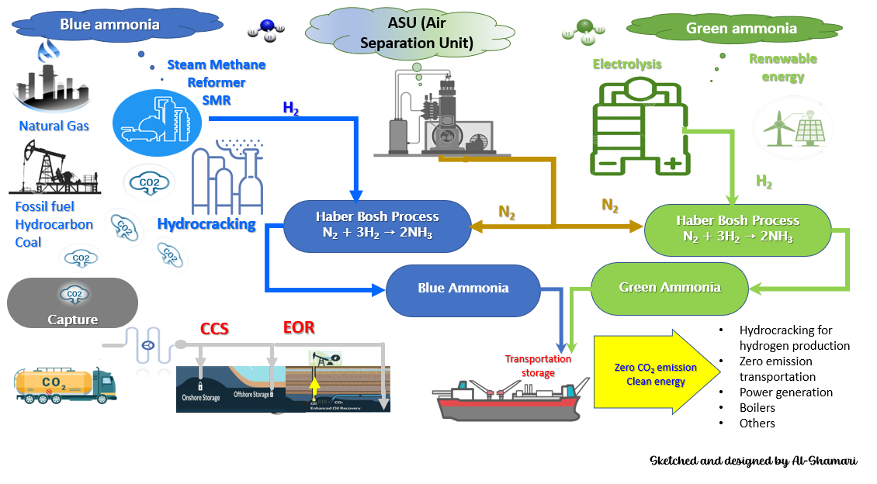
Figure 2: Road map of blue and green ammonia synthesizing, sketched and designed by Al-Shamari

At the 2nd International Fuel for Ammonia Conference in 2022, feasibility studies were conducted for various regions worldwide. It was found that the Middle East and North America are considered to be the optimal regions for blue ammonia production due to their low cost of natural gas and long-term storage capacity for blue ammonia, as shown in Figure 3.

- Blue ammonia at Qatar, a case study
Qatar is embarking on constructing the largest blue ammonia plant in the world to diversify and expand its energy sector. As one of the largest exporters of LNG and rapidly growing its north field, QatarEnergy plans to take advantage of its experience in gas by adding blue ammonia. The new plant (Ammonia-7 Project) will have the capability of producing 1.2 million tons of blue ammonia per year (MTPA). This major project in the blue ammonia industry is expected to start operating in the first quarter of 2026. This new "Ammonia-7" plant will be located in Mesaieed Industrial City (MIC), as shown in figure 4. and will be managed by QAFCO as part of its integrated facilities. With an annual production capacity of 3.8 million MT of ammonia and 5.6 million MT of urea, QAFCO is already ranked among the top ammonia and urea manufacturers worldwide. QatarEnergy Renewable Solutions (QERS) will develop and manage integrated CCS facilities that can capture and sequester approximately 1.5 million tons of CO₂ per year to support the new Ammonia-7 plant. Furthermore, the Ammonia-7 facility will receive more than 35 MW of renewable electricity from its PV Solar Power Plant in MIC (QNA – Qatar 2022).
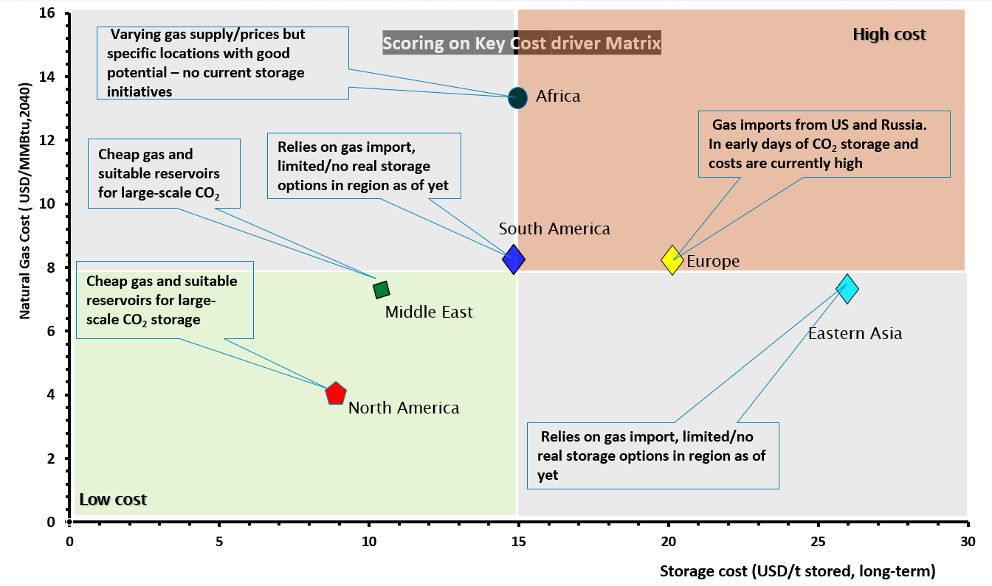
Figure 3. Differences in regional competitiveness of blue ammonia driven by gas, CO₂ storage costs
and incentive mechanisms, source: 2nd International Fuel for Ammonia Conference – 2022.

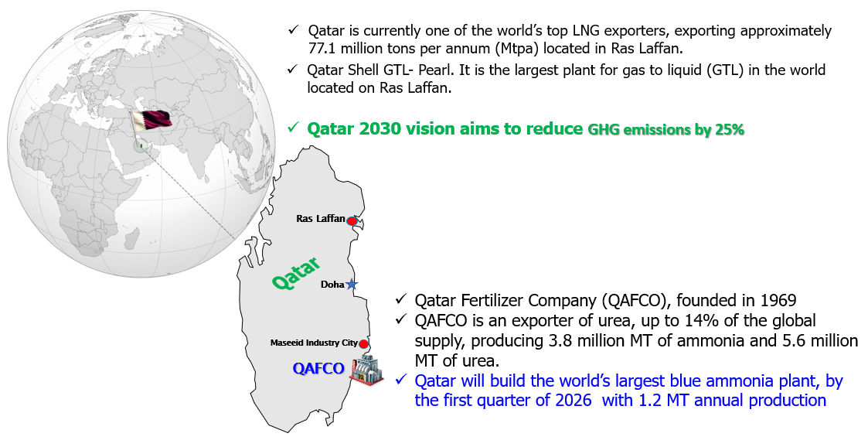
Figure 4. location of blue ammonia in Qatar – Data source: (QNA – Qatar 2022).

- Conclusions
The largest blue ammonia plant in the world will be completed in Qatar by the first quarter of 2026, with 1.2 million tons of blue ammonia annually (MTPA) production. Low-carbon ammonia has the potential to significantly reduce greenhouse gas emissions in several industrial sectors this decade. The versatile substance, made with a low carbon footprint, can be utilized in agriculture, transportation, and power generation. Among these industries, fertilizers, and transportation are particularly critical. The widespread traditional ammonia production and transportation networks provide experience, standards, and immediate economic benefits for low-carbon ammonia, especially in the fertilizer industry. There are no technical or natural resource limitations to the widespread use of low-carbon ammonia before 2030. It can be produced using low-carbon hydrogen and the Haber-Bosch process. However, rules in electrolysis processing and site restrictions for generating zero-carbon power will need to be addressed if green hydrogen production is to expand quickly. In addition, the availability of blue hydrogen is primarily limited by CO₂ transportation and storage access, which can be improved through integrated carbon capture in existing ammonia production units and new projects. The cost comparison between blue and green ammonia will vary depending on local factors such as the cost and availability of low-carbon power, natural gas costs, and proximity to CO₂ storage.
6 References
Cechetto, V., L. Di Felice, J. A. Medrano, C. Makhloufi, J. Zuniga and F. Gallucci (2021). "H₂ production via ammonia decomposition in a catalytic membrane reactor." Fuel Processing Technology 216: 106772.
Cloete, S., O. Ruhnau and L. Hirth (2021). "On capital utilization in the hydrogen economy: The quest to minimize idle capacity in renewables-rich energy systems." international journal of hydrogen energy 46(1): 169-188.
Clarksons, Data website IAn introduction to Green Ammonia | 13.06. 2022
David Sandalwood - Ammonia Roadmap report - COP27 in November 2022
Ernst, F. A. (1928). Fixation of atmospheric nitrogen, D. Van Nostrand Company.
Faheem, H. H., H. U. Tanveer, S. Z. Abbas and F. Maqbool (2021). "Comparative study of conventional steam-methane-reforming (SMR) and auto-thermal-reforming (ATR) with their hybrid sorption enhanced (SE-SMR & SE-ATR) and environmentally benign process models for the hydrogen production." Fuel 297: 120769.
Hammad, A. and I. Dincer (2018). "Analysis and assessment of an advanced hydrogen liquefaction system." International Journal of Hydrogen Energy 43(2): 1139-1151.
International Energy Agency. Ammonia Technology Roadmap. (IEA, Paris, 2021 https://www.iea.org/reports/ ammonia-technology-roadmap).
International Renewable Energy Agency (IRENA). Green Hydrogen Cost Reduction: Scaling up Electrolysers to Meet the 1.5 _C Climate Goal. 2020. Available online:https://irena.org/-media/Files/IRENA/Agency/Publication/2020/Dec/IRENA_
Green_hydrogen_cost_2020.pdf]
International Energy Agency. Ammonia Technology Roadmap. (IEA, Paris, 2021 https://www.iea.org/reports/ ammonia-technology-roadmap).
Hånde, R. and Ø. Wilhelmsen (2019). "Minimum entropy generation in a heat exchanger in the cryogenic part of the hydrogen liquefaction process: On the validity of equipartition and disappearance of the highway." International Journal of Hydrogen Energy 44(29): 15045-15055.
Laskin, J. B. and R. D. Feldwick (1978). "Recent development of large electrolytic hydrogen generators." International Journal of Hydrogen Energy 3(3): 311-320.
Lim, J., C. A. Fernández, S. W. Lee and M. C. Hatzell (2021). "Ammonia and Nitric Acid Demands for Fertilizer Use in 2050." ACS Energy Letters 6(10): 3676-3685.
qna.org.qa Qatar Builds World's Largest Blue Ammonia Facility
Rouwenhorst, K. H. R., A. S. Travis and L. Lefferts (2022). "1921&ndash;2021: A Century of Renewable Ammonia Synthesis." Sustainable Chemistry 3(2): 149-171.
Scott, E. K. (1923). "Nitrates and Ammonia from Atmospheric Nitrogen. Lectures III." Journal of the Royal Society of Arts 71(3704): 900-917.
Statista, Production capacity of ammonia worldwide from 2018 to 2021, with a forecast for 2026 and 2030. https:// www.statista.com/statistics/1065865/ammonia-production-capacity-globally/ (Accessed September 2022).
Travis, A. S. (2015). The synthetic nitrogen industry in World War I: Its emergence and expansion, Springer.
Travis, A. S., A. S. Travis and Costa (2018). Nitrogen capture, Springer.
Van Rooij, A. (2005). "Engineering contractors in the chemical industry. The development of ammonia processes, 1910–1940." History and technology 21(4): 345-366.
Wang, M., M. A. Khan, I. Mohsin, J. Wicks, A. H. Ip, K. Z. Sumon, C.-T. Dinh, E. H. Sargent, I. D. Gates and M. G. Kibria (2021). "Can sustainable ammonia synthesis pathways compete with fossil-fuel based Haber–Bosch processes?" Energy & Environmental Science 14(5): 2535-2548.

